For further information see regional information listed at:

[www.cfdm.org](http://www.cfdm.org)

We provide ongoing events within regions for groups and individuals, such as monthly quiet days, quarterly renewal weekends, annual conferences, enrichment workshops, and other formational opportunities.

If you are looking for a spiritual director within the western states of the USA, or are interested in training to be a Director and desire community and support with other Christian Directors, get in touch with us today!

[](http://us.123rf.com/400wm/400/400/fintastique/fintastique0802/fintastique080200293/2570074.jpg)

*"Our real journey in life is interior;   
it is a matter of growth, deepening, and an ever greater surrender to the creative action of love."   
  
-- Thomas Merton*

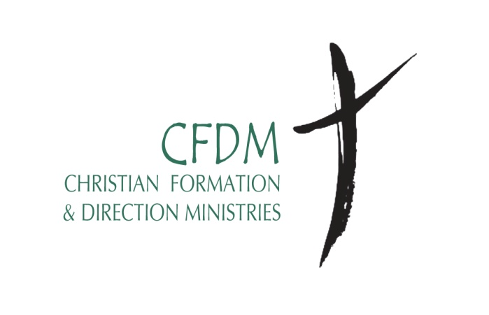

**Two-Year Certificate Program in**

**Christian Formation and Spiritual Direction**

**Los Angeles**

**Christian Formation & Direction Ministries** [CFDM] is a non-profit Christian ministry incorporated in California in 1996. Our mission is to “***lead others into a deeper love for and intimacy with the Father, Son, and Holy Spirit through spiritual formation and the art of spiritual direction…particularly through the training, re-sourcing, networking, and supervising of spiritual directors for Christian churches in the United States***.”



**The goal of the Certificate Program in Christian Formation and Spiritual Direction is**

* To mature into deeper intimacy and friendship with the Triune God.
* To develop a theology of Christian spirituality by drawing on and integrating insights from Scripture, theology, historical traditions, psychology and related fields.
* To discover the richness of one’s own spiritual tradition, as well as the gifts and blessings of other traditions.
* To learn about, and engage in, spiritual habits and practices that facilitate spiritual growth.
* To grow in balancing prayer, study and service and in developing practical wisdom based on Scripture, tradition, reason, and experience.
* To gain experience and skills in providing individual and group spiritual direction in a Christ-centered program and context.
* To participate in a creative partnership among Christian spiritual directors in regional networks of CFDM.

**WHO SHOULD APPLY?**

* Those with a desire to develop a deeper interior life with God
* Those with a passion to discover God's works in forming His followers
* Those who desire to listen to and journey with other's spiritual life
* Those discerning a calling as a spiritual director

**Structure of the Two-Year Program**

**2014 Meeting Dates:**

* **January 28-31**
* **April 29- May 2**
* **August 26-29**
* **October 21-24**

**First Year Requirements**:

During this first year the focus is on spiritual formation and the tools for becoming a spiritual director. In addition to class attendance and participation, the student will:

* write a spiritual autobiography
* be in spiritual direction each month
* develop the rhythm of a monthly

quiet day

* write reflection papers on reading and spiritual experience.

**Second Year Requirements:**

For those continuing in the program, the focus of year two is on practical training as a spiritual director.

This includes:

* Two 3 1/2-day gatherings
* monthly supervision meetings
* monthly spiritual direction
* monthly Quiet Days
* written reflections
* monthly supervision for direction practice
* participation in a network of

spiritual directors

# **Costs:**

Tuition for the two-year program is $3,800. In the first year [$2,200], tuition covers 16 days of instruction and practicum, refreshment/snacks, noon meals, faculty resources, administrative costs, reprints and other materials. In the second year [$1,600], tuition covers 6 days of food and one overnight lodging at a retreat center, faculty resources, administrative costs, reprints and other materials, and monthly supervision. Not included are overnight accommodations for classes and retreats in the first year, if needed, fees for individual spiritual direction and monthly personal quiet days. $50 non-refundable & transferable application processing fee and $300 non refundable tuition payment is due at time of admission to the Program [to reserve a place—space is limited] and tuition for the program is due in advance on a yearly or quarterly basis or by arrangement.

# **Admission Requirements**

Admission is open to individuals [lay or clergy] from any Christian denomination or group who have a bachelor’s degree or its equivalent and/or have training or foundational knowledge of Scripture and theology. Life experience is highly valued as is awareness of a potential call to be a spiritual director. Admission to the program requires:

* A completed application form
* A statement detailing educational background, work experience, Christian journey, involvement in church and Christian service, and interest in the program and in being a spiritual director.
* Two letters of reference [one pastoral and one personal]
* Beginning to see a Spiritual Director, if you are not already in that practice.

For more details contact Regional Director,

Rev. Care Crawford ( 818) 788 4210 ext. [care.crawford@belairpres.org](mailto:care.crawford@belairpres.org)